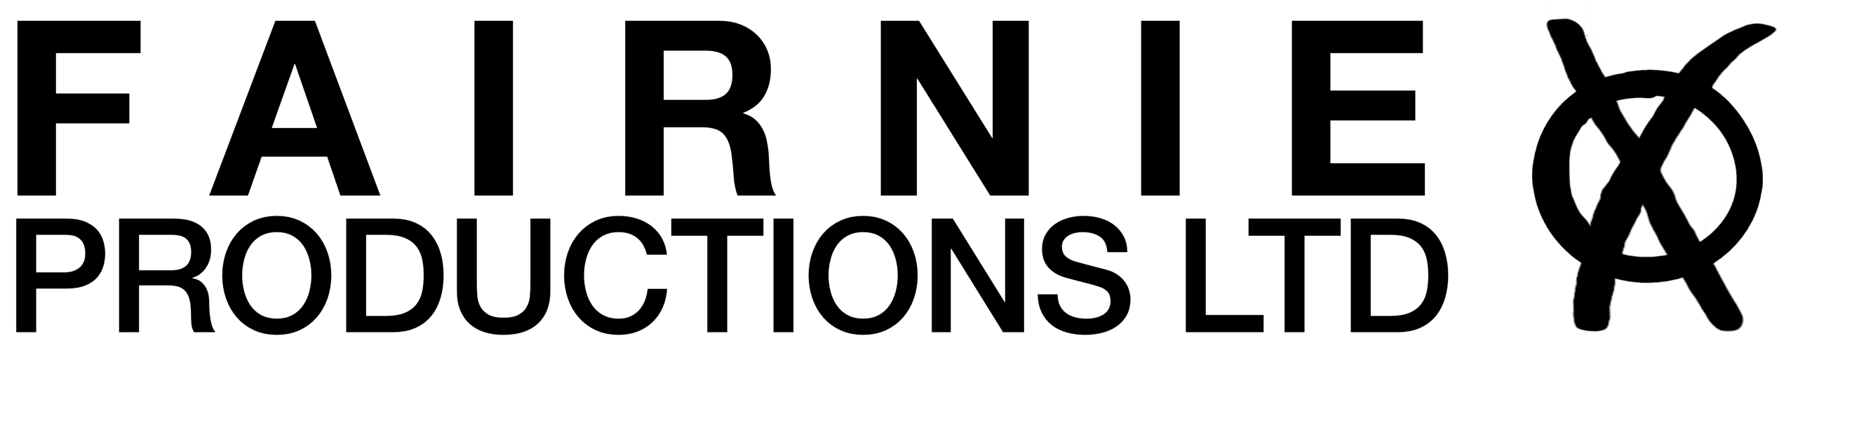

CROWD FILMING RELEASE NOTICE*

Fairnie Productions Ltd will be filming in this area today. Please be aware that by entering this area, you irrevocably consent to your voice, name, image and/or likeness being used, without compensation, for use in any and all media. You release Fairnie Productions Ltd, its successors, assigns and licensees from any liability whatsoever of any nature.

IF YOU DO NOT WISH TO BE FILMED OR PHOTOGRAPHED, PLEASE DO NOT ENTER THIS AREA AND ALERT A MEMBER OF EVENT STAFF.

*Fairnie Productions Ltd is recording this event for promotional material, printed and online. The audience of the produced materials may include students, academics, members of the public, policy-makers, funders and other stakeholders.

